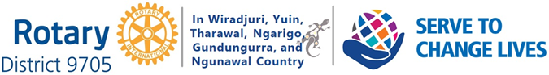

SATURDAY MAY 15^{th.} 2021 in YOUNG

USEFUL INFORMATION

Club Service Projects Committee Basics (4 courses)

https://learn.rotary.org/members/learn/lp/11/club-service-projects-committee-basics

Service Projects (13 items with a total of 50 courses)

https://learn.rotary.org/members/learn/catalog/view/73

My Rotary

https://my.rotary.org/en

RI District 9705

https://rotary9705.org.au/

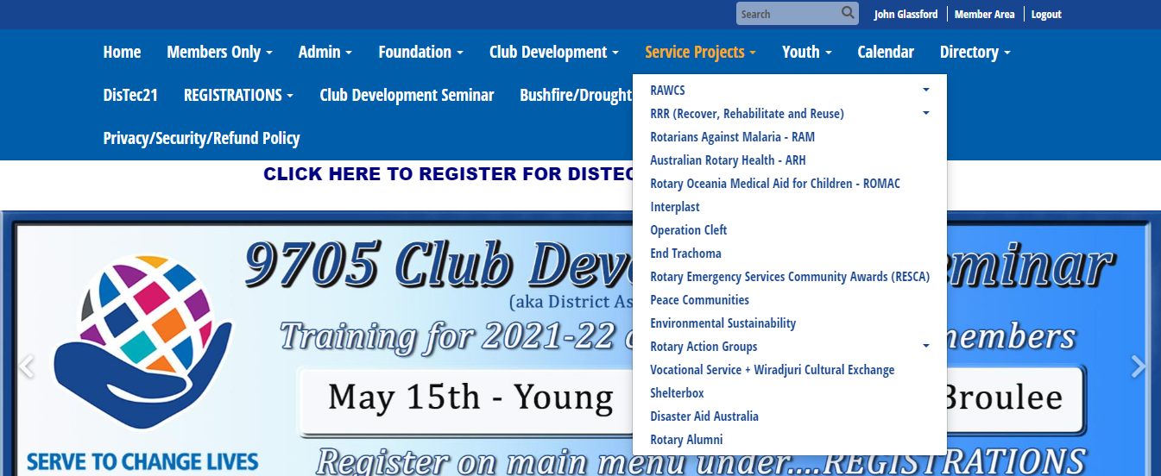

The Role of the Service Projects Team Leader includes:

Ensuring the smooth operation of the District through supporting effective and targeted community service projects, their management and development, by:

- providing support for the individual Service Projects to deliver their service projects to our District,
- sharing information about the Service Projects with the District leadership team,
- encouraging Service Project Champions to utilise District mechanisms to inform local
- Rotary clubs, Rotarians, and broader communities, and
- taking to the Governor any existing or emerging issues that may flag a potential risk for
- the organisation, District and/or Rotary International.
- The Service Projects (listed below), their Champions, Objectives and Contacts (listed in each
- Service entry following) are generally District Wide Projects that and do not stop individual Clubs having their own Service Projects which they support to varying degrees.

These District Wide Projects are:

1. Rotary Australia World Community Service (RAWCS) – including Bushfire Recovery
Project and Drought Steering Project

2. Triple R [Recover, Rehabilitate Reuse] + Donations in Kind (DIK)

3. Rotary Against Malaria (RAM)

4. Australian Rotary Health (ARH)

5. Rotary Oceania Medical Aid for Children (ROMAC)

6. Probus

7. NSW/ACT Rotary Emergency Services Community Awards (RESCA)

8. Shelterbox

9. Rotary Action Groups

10. Rotary Fellowships

11. Peace Communities

12. End Trachoma by 2020

13. Disaster Aid

14. Rotary Alumni

15. Vocational Service – Group Study Exchange

RI District 9705 Service Projects Team Leader
PDG Michael Milston (Orange Daybreak)
governor9700milston@bigpond.com

0419 414 959

ROTARY SERVICE OPPORTUNITIES

Make sure members know about these service opportunities:

PolioPlus — Rotary’s corporate program that supports global polio eradication efforts.

Interact — Service club for young people ages 12-18, sponsored by a local Rotary Club.

New Generations Service Exchange — Highly customized vocational or humanitarian service-related exchanges between two Rotary districts for adults up to age 30.

Rotaract — Service club for young men and women ages 18-30, sponsored by a local Rotary club.

Rotarian Action Groups — International groups of Rotarians, Rotarian spouses, and Rotaractors who join together to conduct international service projects related to a specific topic.

Rotary Community Corps — Service group of non-Rotarian adults sponsored.by a local Rotary club.

Rotary Fellowships — International groups of Rotary members, their spouses and Rotaractors who join together to pursue a common recreational or vocational interest.

Rotary Friendship Exchange — International exchange program for Rotarians and their families that promotes relationships that can evolve into international partnerships for service projects.

Rotary Peace Centres — International education program that offers a master’s degree or professional development certificate in peace and conflict resolution; qualified candidates study at one of several established Rotary Peace Centres.

Rotary Youth Exchange — International exchange program that promotes international understanding and peace among students ages 15-19.

Rotary Youth Leadership Awards (RYLA) — Local training program for young people that emphasizes leadership, citizenship, and personal growth.

Rotary Grants — Funding available to clubs and districts for humanitarian service and educational projects.

ROTARY’S 7 AREAS OF FOCUS

When planning your projects, choose a community need that falls within Rotary’s service priorities:

- Peace and conflict prevention/resolution
- Disease prevention and treatment
- Water and sanitation
- Maternal and child health
- Basic education and literacy
- Economic and community development
- Supporting the Environment

My Club:
Our regular service projects:
New Services I think our community needs:
Rotarian views on Service projects:
What 3 words does my community think of when describing Rotary’s impact in/on our community?
Notes
WORK SHEET

